HTP BLE Assignment

1. Advertising Period = 244 ms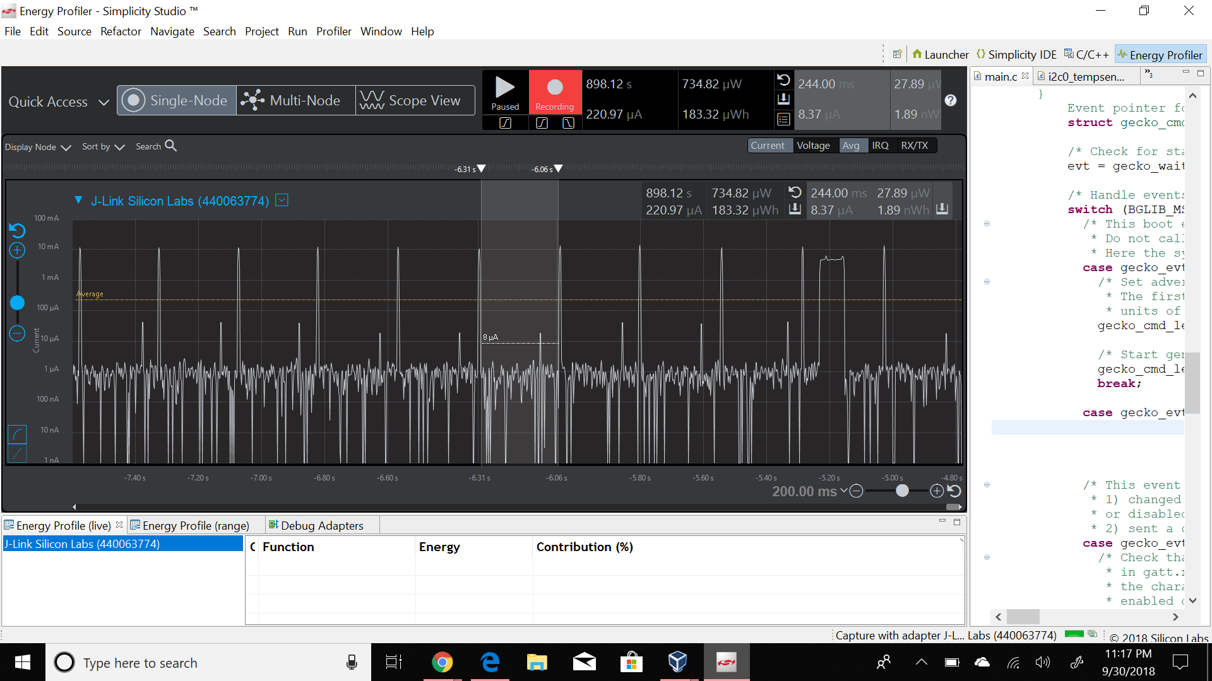
2. Connection Interval = 74 ms

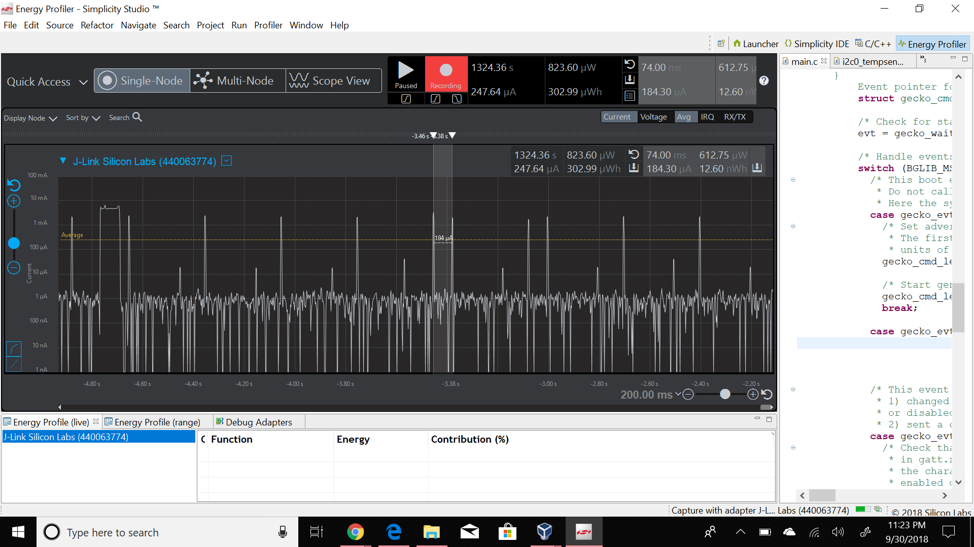

1. Slave Latency = 296 ms

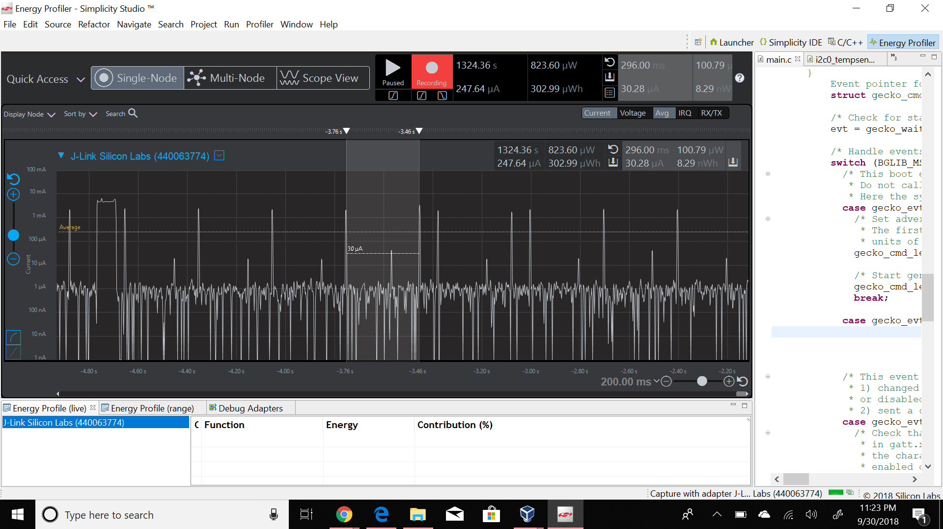

1. Average current between advertisements is 1.69 µA.
2. Average current between connection intervals is 1.01 µA.
3. Peak current of an advertisement is 24.12 mA.
4. Peak current of a data transmission when phone is placed next to Blue Gecko is 6.01 mA.
5. Peak current of a data transmission when phone is placed next to Blue Gecko is 6.06 mA.